HUMAN RESOURCE MANAGEMENT PLAN

Course: ELP 553: Organizational Management I- Human Resource Management

Professor: Dr. Gregory Hicks

North Carolina State University
Fall 2019

Leshaun T. Jenkins
DPI pre-service descriptors (Examples listed below) | Leadership Project Evidence (What you did to meet each descriptor) | Reviewers:  Met/Not Met  (  )
Standard 2: Instructional Leadership  2b1. Adheres to legal requirements for planning and instructional time | - Conducted focus groups with teachers and administrators to ascertain scheduling processes and effectiveness in maximizing instructional time for improved student achievement.  - Interviewed staff members, administration, and selected Professional Learning Communities (PLCs) to determine level of staff input into scheduling and administrative support for staff input.  - Observed multiple school activities, e.g., lunch, class changes, teacher planning times, PLC meetings, athletic events, school starting and ending procedures, etc. to monitor and analyze scheduling effectiveness.  Field Exp. Reviewed scheduling process for school identifying the boundaries like lunch, planning etc.
Standard 4: Human Resource Leadership  4c1. Works with others to provide formal feedback to teachers concerning the effectiveness of their classroom instruction and ways to improve their instructional practice. | - Reviewed the North Carolina Teacher Evaluation Instrument.  - Arranged to observe two colleagues outside my teaching area, scheduling pre-conference meetings, observations, and post-conference meetings.  - Videotaped at least one post-conference meeting.  - Utilized the McRel on-line evaluation tool when accessible.  Field Exp. Completed an Observation Cycle including pre and post conferences
Standard 4: Human Resource Leadership  4c2. Works with others to implement district and state evaluation policies in a fair and equitable manner. | - Analyzed current staff evaluation processes against best practices to determine effective teacher improvement through professional development.  - Reviewed procedures for various teacher improvement plans, i.e., directed, monitored, and mandatory improvement plans.  - Discussed teacher dismissal as per GS 115C-325.  Field Exp. Interviewed Special Ed Director for compliance concerns

Part I
TARBORO HIGH SCHOOL
PROFILE

TARBORO HIGH SCHOOL’S MISSION STATEMENT

The Tarboro High School Community will work together to build positive relationships with all stakeholders and prepare students to achieve personal success in an ever changing society.

TARBORO HIGH SCHOOL’S VISION

Our belief, “Tarboro High: A School of Promise, Pride, and Purpose”, allows the faculty to create a collaborative educational setting that prepares our students for the 21st Century.

Student Demographics
Grade Level | Total # of Students | African-American | White | Asian | Hispanic | Male | Female
9th | 134 | 102 | 14 | 0 | 13 | 75 | 58
10th | 122 | 82 | 27 | 1 | 10 | 73 | 49
11th | 148 | 114 | 19 | 0 | 6 | 70 | 78
12th | 117 | 85 | 17 | 0 | 12 | 58 | 59
Totals | 520 | 383 | 77 | 1 | 41 | 276 | 244
Percentages | - | 73.6% | 14.8% | .3% | 7.8% | 53% | 46.9%

The demographics of our school is very interesting to me. Historically Tarboro HS has always been pretty diverse since integration back in 1970. Over the years there has been an increase in African-American representation, and a decrease in the White population. There is Hispanic representation, but little to no representation of other subgroups. Tarboro High School is overwhelmingly African-American. Our largest class is our junior class. They are closely followed by our freshman class. Sophomores fall in as our third largest class. Our smallest class is our senior class. One thing that I find interesting.
Staff
Tarboro High School Human Capital Table
Staff Member Name | Title of Role Within the School | Areas of Certification | Total Years of Experience | Years at THS | Work Location or Room # | Current Assignment
Leshaun Jenkins | Assistant Principal  African –American Male | 9-12 Social Studies; Admin. License | 19 | 17 | AP Office | Assistant Principal
Cassandra Conger  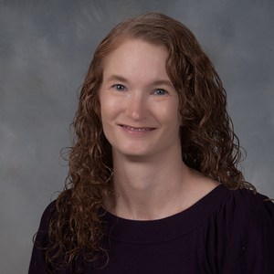 | Teacher  Caucasian Female | Grades 6-12 English / Language Arts | 15 | 5 | 113 | Teacher
Terry Shackleford  Picture Unavailable | Testing Assistant  Caucasian  Male | Curriculum Specialist, School Counseling | 20+ (Retired) (Previous: 9+ Funeral Service) | 1 | 123 | Testing Assistant
Chioma Pitts  Picture Unavailable | Teacher  African American Female | Family & Consumer Science | 6 | 3 | 130 (Back Building) | Teacher
Lynell Perry  Picture Unavailable | Teacher  African American Male | Social Studies 6-8  Social Studies 9-12  EC ELA K-12  EC Math K-8  EC SS K-12  EC Science K-12 | 16 | 1.5 | 103 | Teacher
Miles Stafford | Teacher  Caucasian Male | Biology; General Sciences  (9-12) | 9 | 8 | 119 | Biology Teacher
Pamela Rose | Teacher  Caucasian Female | Biology (10-12), Middle Grades Science (6-9) | 12 | 2 | 118 | Teacher
MSgt Robert Garrett  Picture Unavailable | Aerospace Science Instructor  Caucasian  Male | (9-12) Aerospace Science, Leadership,  Physical Fitness, Survival,  Management | 15 | 3 | 204 | Aerospace Science Instructions tor
Jimmie Harris  Picture Unavailable | Teacher  African American Male | Marketing Ed.  Business Ed. | 22 | 4 | 210 | Marketing Teacher
Rebecca Mills  Picture Unavailable | Teacher  Caucasian Female | Music K-12, EC Adapted Curriculum K-12, EC General Curriculum K-12, Elementary Education K-6, Reading K-12 | 12 | 3 | 107 | Teacher
Pippa Bryant  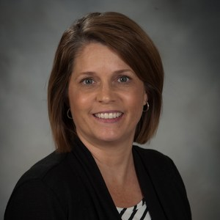 | Media Coordinator  Caucasian Female | - Elementary Ed K-6  - Reading K-12  - Media Coordinator K-12  - Curriculum Instructional Specialist K-12  - School Administration K-12 | 26 | 13 | 116  Media Center | Media Coordinator
Amanda Morris  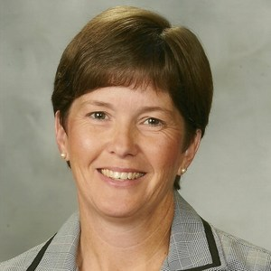 | Teacher  Caucasian Female | Secondary English  Middle Grades Education (ELA and Social Studies) | 26 | 2 (this is year 3) | 112 | English teacher
Natasha Cherry | EC Teacher  African American Female | EC Teacher | 10+ |  | Room 206 | Teacher
Jessica Jones  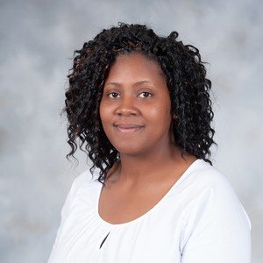 | Teacher  African American Female | FCS 9-12, | 20 | 16 | Room 205 | Foods 1 & Culinary Arts 1
James Williams 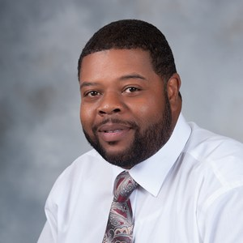 | Business Teacher  African American Male | Business | 11 | 8 | 211 | Business Teacher
Ricky Babb  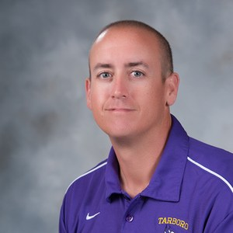 | Teacher  Caucasian Male | History Education Grades 6-12 | 18 | 12 | Room 105 | American History Teacher
Chris Siggins  Picture Unavailable | Teacher  Caucasian Male | English Language Arts Secondary Education | 1 | 1 | 111 | ELA Teacher, Engl I/ Engl III
Dazzala Cofield  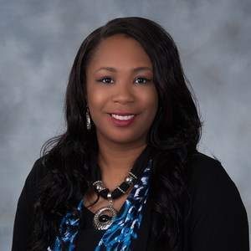 | Teacher  African American Female | Arts | 12 | 12 | 224 | Teacher
Anthony Burns  Picture Unavailable | Teacher  Caucasian Male | Health / PE K-12 | 11 | 4 | 160 | Teacher
Ashley Davis  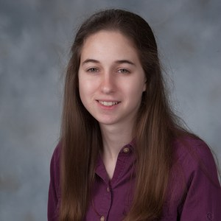 | Teacher  Caucasian Female | Secondary Math Education | 5 | 5 | 128 | Math Teacher
Vicky Bolivar  Picture Unavailable | Spanish Teacher  Hispanic Female | Spanish Teacher | 5 | 5 | 109 | Spanish Teacher/Volleyball coach
Jamie Willoughby  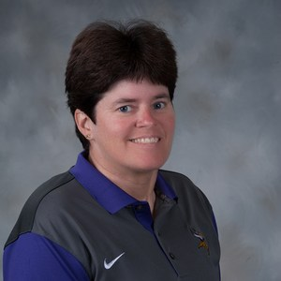 | H/PE Teacher; G. Weightlifting; AD; Coach  Caucasian Female | Health/PE K-12 | 25 | 25 | 161 | Teacher/Coach
Andrew Harding  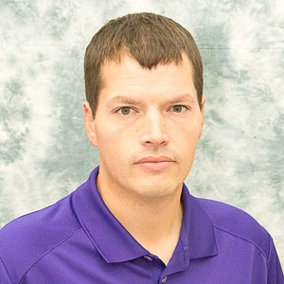 | Social Studies Department Chair  Caucasian Male | Civics and Econ, American History I and II | 14 | 11.5 | 106 | Teacher and Coach
Viola Gilbert  Picture Unavailable | School Counselor  African American Female | School Counseling  School Administration | 20+ | .5 | Counseling Department | School Counselor
Cory Kimball  Picture Unavailable | Teacher  Caucasian Male | American History, World History, Civics and Economics | 3 | 3 | 104 | American History Teacher
Major Wilson  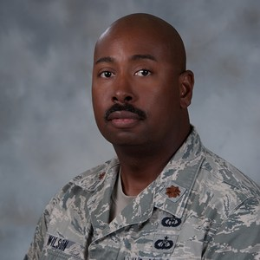 | Senior Aerospace Science Instructor  African American Male | (9-12) Aerospace Science, Leadership,  Physical Fitness, Survival,  Management | 30+ | 5 | 204 | Senior Aerospace Science Instructor, SIT Team, Academic Excellence Committee, Admission Liaison Officer United States Air Force Academy
Hillary Boutwell  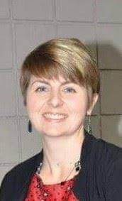 | Assistant Principal  Caucasian Female | K-12 Music Education, Administration and Supervision (MAEd), Educational Leadership w/ Curriculum and Instruction (EdD) | 10+ | 4 | 147 | Assistant Principal
Donna Hunter  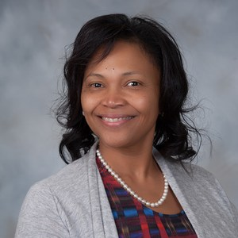 | Teacher  African American Female | Math  Science  History | 20+ | 5 including 2019-2020 | 126 | Math teacher
M. Atkinson-Skinner  Picture Unavailable | Teacher  Caucasian Female | ELA | 3 | 3 | 114 | teacher
Antonio Suggs  Picture Unavailable | Drivers Education Coordinator  African American Male |  | 19.5 | 19.5 | Front office | Drivers Education Coordinator
Tequilla Taylor  Picture Unavailable | Teacher  African American Female | ELA 6-12  EC LD K-12 | 15 | 3 | 110 | English Teacher
Ryan Braley  Picture Unavailable | Teacher  Caucasian Male | Math | 6 | 2.5 | 124 | Teacher
Sharon Bailey  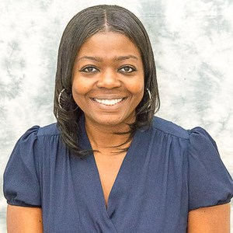 | School counselor  African American Female | English (6-12)  History (6-12)  School Counselor  (K-12) | 15 | 5 | Student Services -152 | School counselor
Linda Draughn  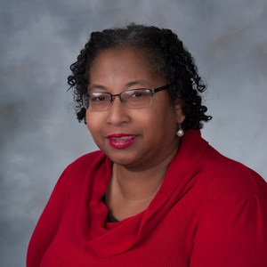 | EC Teacher  African American Female | Social Studies 9-12,  Adapted Curriculum K-12  General Curriculum  K-12  Special Education  Birth-21 | 29.5 | 20 | 220 | EC Teacher
Terry Hopkins  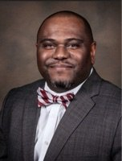 | Principal  African American Male | School Counseling; Masters in School Administration
Jacqueline Pearce | Office Assistant | Birth to Kindergarten  Educational Studies | 24  5 | 5 | Front Office  Room 140 | Secretary
Reggie Bess  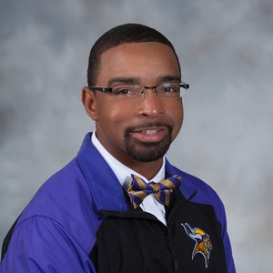 | CTE Teacher  African American Male
Jeff Craddock  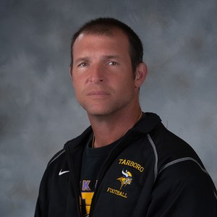 | PE Teacher  Caucasian Male | 9-12 Social Studies; Physical Education |  |  |  | Weightlifting
Rachel Davis  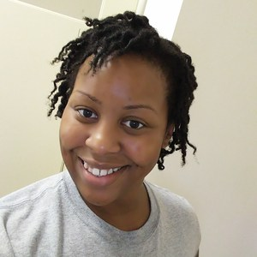 | Science Teacher  African American Female | 9-12 Science | 7 years | 4 years | 117 | Chemistry/Honors Earth
Dawn Cuthrell | Career Development Coordinator  Caucasian Female | Family & Consumer Sciences Education 6-12, Career Development Coordinator 6-12, Handicapped Disadvantaged 6-12 | 27 years | 5 years | Student Services 153 | CDC/SPC
Tiffany Georgic  Picture Unavailable | ESL Teacher  Caucasian Female | Birth-12 TESOL | 18 | 3 | Room 125
Zachary Parrisher  Picture Unavailable | CTE Teacher  Caucasian Male | Business Education  Marketing Education | 4 | 1 | Room 214 | Business Teacher
Chonell Shaw  Picture Unavailable | Office Manager  African American Female |  | 20 | 20 | Room 145 | Bookkeeper

Faculty & Staff
Our staff at Tarboro High School is pretty diverse. Our staff is a good blend of BT’s mixed with seasoned veterans. We only serve 520 students so therefore we do not have large high school in terms of numbers, but we are a large school in terms of what we offer. Below you will find a breakdown of our departments. Though our departments are relatively small, it creates a greater opportunity for cohesion and collaboration. It also creates a more intimate relationship amongst staff members when it comes to PLCs and other school wide happenings such as our School Improvement Team.
English Department | 5
History Department | 4
CTE Department | 8
ROTC | 2
Math Department | 4
Art/Humanities Department | 2
Science Department | 4
Physical Education Department | 3
Administration | 3
Guidance Department | 2
Front Office Department | 4

Free and Reduced Lunch
100% of our students received free and reduced lunch. We are part of federal initiative that provides free and reduced lunch to low-income school districts and high poverty LEAs. The beauty of this is that every child receives the opportunity to eat breakfast and lunch free of charge. The disadvantage is that your food options are marginalized. Based on the feedback from students, sometimes the food options are not as selective as they would like. Nevertheless, this is a wonderful program for our students who otherwise would encounter challenges paying for lunch every day.

Achievement
The past two years Tarboro High School has missed being a C school by one point. Over the past couple of years, we have seen significant gains in our Biology schools. Part of that can be attributed to the Opportunity Culture Design. A MCL (multi-classroom leader) position was added specifically for science and it seemed to have worked. We also significant gains in English II. On the flip side of that we saw a significant decrease in our ACT scores & ACT Work Keys results. We have done some things in our schedule to specifically address some of these loopholes in our school data. For example, we have integrated ACT Prep classes into our master schedule. We have tightened up our PLC systems in hopes of creating a tighter system of collaboration which hopefully help us to share best practices across departments. Below you will see our accountability data for the past two years.
Subject Area | 2017-2018 | 2018-2019
Biology | 12.7% | 23.2%
ACT | 18.5% | 15.6%
Work Keys | 55.7% | 37.7%
English | 26.6% | 32.2%
Cohort Graduation Rate | 76.8% | 77.6%
Math Course Rigor | 91.2% | 89.6%

Working Conditions Analysis
97.3 (43/44) Teachers responded to the Work Conditions Survey at Tarboro High School. The working conditions data was very interesting. Some areas indicated that teachers where not very happy with the culture and climate at the school while others seemed to be content with what was happening at the school. For example: 67.4% of teachers did not feel that teachers were recognized as educational experts. That is a large percentage of the staff who feel this way. Only 82.9% of the staff felt that teachers were effective leaders in the school. Only 71.4% of the teachers felt that they have an appropriate level of influence on decision making in the school. The results of the TWC survey was interesting in the area of Teacher Leadership. In the area of School Leadership only 78.6% of the staff felt that there was an atmosphere of mutual respect in the school. Only 72.1% of the teachers said that they feel comfortable raising issues and concerns that are important to them. In terms of Professional Development, only 72.5% felt that there was appropriate follow-up from PD training. 68.3% of the teachers felt that there were ongoing opportunities for teachers to work with colleagues to refine teaching practices. As you can see the data indicators were very interesting, but very helpful in understanding where the cultural shifts needed to happen.
HR Practices/Recruitment/Selection

At Tarboro High School recruitment and selection has not always been successful. As a former Teacher at the school that I am currently the Principal Resident at, I can say with accuracy that sometimes we got the hiring right, and sometimes we didn’t. When I look at all the great teachers who have graced the hallways at Tarboro High School, the list is phenomenal. I think about people like Matt Smith, the reigning State Principal of the Year for NC. I think about NELA graduates like Viola Gilbert, our current guidance counselor. I think about current ECPS administrators like Billy Strother, Deneasha Strother, Shavon Brown, and more who have made and left positive legacies. But I also think about the teachers, whose names I want list, who ended up as classroom disasters. I have sat on many interviews as a former Department Chair.
When we are interviewing potential candidates, there is typically a set of questions that we have reviewed prior to the interview that we try to follow. Sometimes other questions are birthed through those questions that may not be on the list. In that instance, we just go with the flow. It may give the candidate an opportunity to share something that we otherwise would not have known, because it was not one or the original questions. Our focus is usually also on trying to select the candidate will be a good fit for our school in addition to that particular department that they are applying to. This is crucial component. The candidate needs to understand the socio-economical audience of kids that they will be serving. Our kids are unique in a lot of ways and are great kids, but they also bring personal and familial struggles to the table. We have a high number of students who have suffered their own trauma and have to be taught how to self-regulate and navigate through some of that. This is important because it requires strong classroom management skills as well as strong interpersonal skills. These are all components that we keep at the forefront when dealing with HR, hiring, and the selection of the best candidates.
Induction/Orientation
In our district, we have several trainings, inductions, and orientations for our new staff and beginning teachers. Throughout the year there are several required sessions conducted by the district specifically for new teachers or BT’s. There is also a teacher panel that is conducted a couple times a semester that give new teachers or new staff members an opportunity to hear from other teachers as they share best practices from their years of experience. I have served on several of these panels and they are powerful. I have had many teachers who have come back years later to say that insight or advice that you gave on the panel made a big difference in my teaching experience. Also in our Staff Handbook, we have several resource directories that will assist in orientation and induction that will guide teachers in the right direction if and when they have a problem.
Staff Development
Based on needs assessments, TWC surveys, and district needs, Staff Development is always at the forefront of school climate and culture. Some of our PD is required by the district. For example, our district’s No Nonsense Nurturing training is mandatory. It is mandated that all schools send a representative to the training. This PD is connected to and in conjunction with classroom culture and classroom climate. It is a great training and very productive when fully integrated. Other PD offerings generally are offered based on feedback from teachers. Department Chairs report back to S.I.T. members, and we take that information and go from there. Professional Development is critical in developing staff cohesion and capacity.
Instructional Time

Instructional time is extremely important in our building. Teachers are expected to teach from bell to bell. We operate on the four by four model. Teachers teach three classes per day, and they get a 90-minute planning period. Twice per week, on Tuesday and Thursday, all teachers participate in Data PLCs and Planning PLCs. Teachers are required to log their PLC minutes and upload them into their departmental folder weekly. All of this is done electronically.
Personal Analysis

From my analysis of the HR practices at my school, I personally would like to intensify that process. I understand that sometimes you have to take what you can get, but I also feel that your number one priority it to hire the right people. We learned the importance of this concept in Dr. Hick’s class. As I stated earlier, I want to make sure that the professionals that we put in front of kids is our very best. I want to make sure that every child in our building has an opportunity to receive an amazing learning experience in every class. In order to do this effectively, we have to be more intentional in our hiring practices and more selective in how and where we advertise positions. I would not even be opposed to having interested candidates read an article about the culture and climate that we are trying to create at our school, and have them to create a product or at least a plan of action for their classroom that illustrates their comprehension of the vision and mission of our school.
Final Summary
As I draw near the end of Part I of this HR Project. It has for sure forced me to evaluate how we do things in terms of staff that we have in the building. It has forced me to reflect on who is actually in my building and how use them. It has also forced me to go deeper in terms of our hiring procedures and recruitment techniques. If has forced me to reflect on the practices and procedures of how we immerse new staff members and new teachers into the culture and daily functioning of our school. I do believe that there should be practices and procedures in places conducted each semester just in case you have new teachers or long term substitutes who join the staff mid-year or after the semester or school year has begun. Also I think that it is very important to monitor the student report that breakdowns your overall population. This is good for scheduling, understanding data ratios, mater schedule design, and data disaggregation.

