Traffic Light Reflection/Survey
Tarboro High School
Your email address (ljenkins@ecps.us) will be recorded when you submit this form. Not you? Switch account
* Required
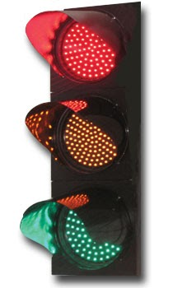
What are some things that need improving at Tarboro High School? *
Your answer
What are some things that we need to discuss or have discussions about at Tarboro High School? *
Your answer
What are some things that are going well at Tarboro High School?
Your answer
Send me a copy of my responses.
Submit
Never submit passwords through Google Forms.

This form was created inside of Edgecombe County Public Schools. Report Abuse
Forms

