SHADOW A STUDENT CHALLENGE

Workbook
Leshaun T. Jenkins (JPLA)

shadowastudent.org

#shadowastudent

Welcome to the Shadow a Student Challenge! This movement is focused on what is most important to our work in K–12 education: the students. This workbook is meant to support you on your Shadow journey, from picking the right student, to capturing your observation and notes from the day, to reflecting and synthesizing what you learned, all the way to taking action.

If you want more information to help you prepare, never fear! You can access a more robust downloadable toolkit with tips, tricks and activities designed to help guide you through this Shadow journey here: https://goo.gl/8Xjums

PREPARE SHADOW REFLECT ACT

STEP ONE
PREPARE

OBJECTIVE

Now is the time to think about your learning goal for this experience, and what student you should seek out for your Shadow a Student experience.

YOU MAY ASK YOURSELF:

What do you hope to learn about your school through this Challenge?

What do you hope to learn about yourself through this Challenge?

What do you hope to see in your school?

MINDSET: Question assumptions

You’ll learn the most from shadowing by having beginner’s eyes instead of coming into the Shadow Day with preconceived ideas of what you expect to see at your school, especially if you’ve taken this challenge before.

Think of this process as starting a design challenge – rather than using your Shadow Day to seek answers to the problems you think you'll find, let the empathy experience of shadowing shine a light on challenges or opportunities at your school.

2

WHAT DO YOU HOPE TO LEARN?

SET A LEARNING GOAL

Creating a learning goal will help you focus your planning for your Shadow Day.
My goal is to observe and identify:
- The infusion of culturally relevant instruction
- Student engagement
- Collaborative learning opportunities
That closes academic achievement gaps and the overt and covert marginalization of minority male students.

EXAMPLES OF PAST LEARNING GOALS

Student engagement: “I want to shadow a quiet student who may go under the radar and get lost in the shuffle.”

College and career readiness: “I want to see what we are doing to prepare our young men for graduation and their futures compared to other students.”

English Learners: “I want to see if English Learners are getting opportunities they want, not just what we think they need.

What are some questions or challenges you're curious to explore by shadowing a student?
Some questions that I am curious to explore are:
- Do you like school? Why or why or why not?
- Do you feel like a valued part of your class?
- Do you feel that your teachers have a genuine interest in you?
- Do you feel that your educational needs are a priority at your school?
- Do you feel confident to participate in class?
6. Do you feel that you possess meaningful relationships with your teachers?

PREP

WHO SHOULD YOU SHADOW?

SELECTING THE RIGHT STUDENT

Your learning experience will depend a lot on the student you shadow.

Looking back at your learning goal, what type of student should you shadow?

year in school | socioeconomic status
academic performance | passions | Personality
The type of student that I should shadow is of course a male student. I should also shadow a student who maybe lacks personal motivation, or who lacks success in the area of academic achievement. This way I will be able to identify the loopholes for the lack of achievement.

STUDENT’S NAME: Bryan Mitchell

GRADE: 9th Grade

3

STEP TWO
SHADOW

OBJECTIVE

The purpose of your Shadow Day is not to observe classes, but to immerse yourself in a student’s experience. Plan to spend the entire day - from bus stop to final bell - walking in the shoes of your student.

YOU MAY ASK YOURSELF:

How can I break the ice with my student before we begin our Shadow Day?

How can I authentically step into the shoes of my student today?

What should I wear or bring to my Shadow Day?

MINDSET: Be student-centered

Try to do everything your student does without judgment. If your student is taking a test, you should take the test too! Have PE next period? Make sure you have gym clothes so you can participate too!

Be curious, ask open-ended questions to

understand their needs, and continue to

look with beginner's eyes at your school.

4

MEETING YOUR STUDENT

GETTING OVER THE JITTERS

Shadowing can feel like the first day of school all over again. You might find yourself questioning your outfit, where to sit during lunch, and what to talk about with your student.

Remember: Your student might feel these things every. single.

day.

WHAT TO WEAR & BRING ALONG

To really put yourself in the shoes of your student:

- Wear their shoes! Swap your dress shoes for some sneakers.

- Stuff a backpack full of gym clothes, books, or whatever supplies you’ll need to do exactly what your student does.

- Don't forget your notebook!

SHADOW

MORE TIPS FOR SHADOWING

QUESTIONS TO SUPPORT YOUR OBSERVATIONS

Think of today as an immersion experience. Your goal for the Shadow experience is to focus on seeing the world through your student's eyes. Think about yourself as a cultural anthropologist, and worry about making sense of your observations later.

Here are some questions you may ask yourself as you record your observations:

Actions

What are students doing in class or in the hallways? What do you observe happening as you move through the day?
Students are socializing with their peers between classes. As they move students are checking their phones, and sending text messages, etc.

Environments

What do you notice about student lockers, hallways, or other spaces students hang out? What do you notice about the classrooms? How does this seem to affect student learning?
The hallways are somewhat narrow; I never really noticed this. Locker space is extremely tight. When students hang out in front of their lockers, it makes for high levels of hallway congestion. This may affect students being able to arrive to class on time. Which cuts into their instruction time.

Interactions

How are students interacting with each other? With the teachers? Do these interactions seem routine or special?
This was very interesting. Students interacted more with their peers, but there are times where students are very interactive with staff members. These routines at times seem routine. At times there is some special interactions that I witness.

Objects

What are the objects and devices students have in their environments, and how do they relate to their activities?
Cell Phones and Ear buds! This normally has their undivided attention in the hallways. In the class, students sometimes have Chromebooks if that is what the teacher is using at that moment.

Users

Who is present throughout the day? What are their roles and relationships to your student?
Throughout the day, administrators are very present. Their role is to serve as instructional leaders. Our administrators have a great rapport with students. The SRO is also present around school throughout the day; of course faculty and staff.
STEP THREE
REFLECT

OBJECTIVE

Now that you've undoubtedly learned some interesting new things, it’s time to figure out what all of it means. Taking time to reflect will help you make sense of what you saw, heard, and felt.

YOU MAY ASK YOURSELF:

What was the most memorable experience from my Shadow Day? Why? The most memorable part of my shadowing experience was what I saw in the student. The student had no passion for most of his classes. But I must say that there was nothing to stimulating about his learning experience.

What surprised me? What delighted me?
What surprised me was the tenacity and resilience of the the student. Even in spite of being bored and somewhat disengaged, he still pressed through satisfying all of the requests from his teachers.

How did my experience differ than my expectations?
I expected apathy from the student, but I that’s not what I observed; The student cared about his educational experience, but there wasn’t anything stimulating to make him curious about how it related to him. There were no real world connections.

What did I discover related to my learning goal?
I discovered that that there really wasn’t any culturally relevant literature that was presented or taught. In speaking with the student, this created disengagement or what we can call boredom. I discovered that it was difficult for the student to really put forth 100% into something that he could not make real life connections with. When the student was able to engage in interactions with other students, his entire demeanor changed.

MINDSET: See challenges as opportunities

Immersing yourself in a student’s life can be overwhelming, tiring, and challenging. You may have seen a lot of room for improvement in your student’s experience. That’s great! It means you’ve empathized with them enough to see unmet needs, so that they can be addressed.

In addition to reflecting individually, it can be really helpful to share your observations with fellow colleagues, friends, or other Shadowers. Sometimes talking it out will reveal things you didn't notice when processing your observations alone.

6

REFLECT

TURNING OBSERVATIONS

INTO OPPORTUNITIES

The observations, quotes, and field notes from your Shadow Day can be inspiring catalysts for improving the student experience at your school. Interpreting your observations helps you come up with meaningful opportunities for positive change. Use the worksheet below to start turning your observations into opportunities. A good place to start is by answering the questions on the previous page.

OBSERVATION |  | INTERPRET |  | OPPORTUNITY
Notice, feel, etc. |  | Why is this happening? |  | What does this make you wonder?
I was inactive for most of the day - the only |  | Classtime didnt integrate movement or |  | What is we added a physical/movement
time I moved was for passing persiods. |  | mobility of students. |  | activity into each class?
I noticed that student seldom moved out of their desk. I was wondering what impact did this lack of movement have on the kinesthetic learners in the classroom. It was interesting to see how the students maintained the ability to stay engaged and connected to the instruction being offered by the teachers. |  | I personally believe that the teachers desire to control the space in which they teach in. Because of a lack of a definitive classroom management system, teachers don’t take risk when it comes to classroom movement out of feat of not being able to control the expected outcome. |  | It makes me wonder, just how much of an impact could be made by integrating more collaborative interaction and activities. I wonder how much more effort and pride would kids take in their school experience, if they were allow the voice and choice to utilize space within the classroom as an agent of engagement.

STEP FOUR
ACT

OBJECTIVE

You’re ready to put your learnings into action! Using an opportunity you found, the next step is to come up with manageable ways to make change at your school.

YOU MAY ASK YOURSELF:

What is the most pressing student need that should be addressed?

What's something I can try next week that can help me learn more about my new ideas?

What makes me the most excited about taking action? The most nervous?

MINDSET: Bias to action

While you may be eager to make big changes right away, it’s easier - and starts to address problems quicker - to begin with “quick wins.”

Rather than a full-blown solution, try a “hack”, or experiment, to rapidly test ideas for immediate feedback.

8

WHAT IS A HACK?

A hack is a way to redesign your school culture using small, scrappy experiments called “hacks." It’s about having a big idea, but tackling it in an incremental and informative way. Think "What is something I can try next week that will inform my idea?"

ONE PRINCIPAL’S HACK:

During his Shadow day, Adrian Advincula of Irving Elementary realized:

Kids are doing so much work and we

don’t see that. All the things they do in

class, that process isn’t shared.

He wanted to help families and communities see student learning, not just the end product. So he chose a small hack to make student learning visible.

Want to see more examples of hacks educators have done in the past?

Visit http://shadowastudent.org/how-it-works#Act-Section for more.

ACT
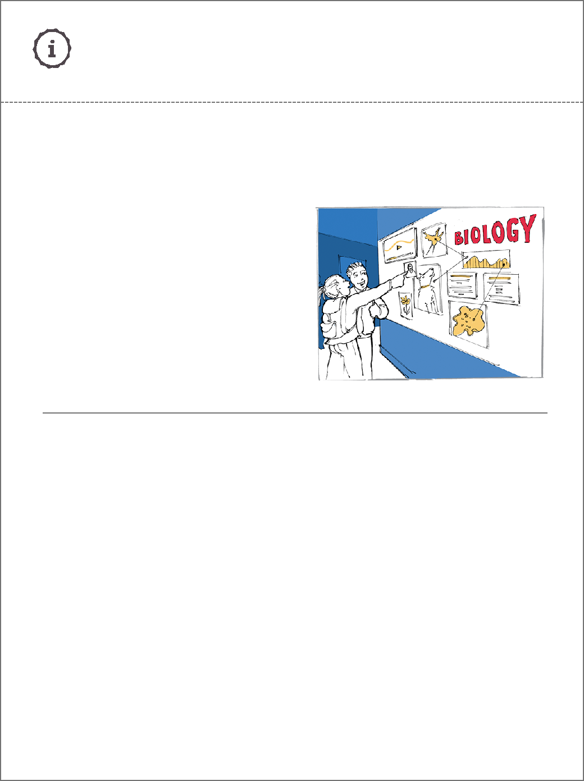

If your insight is about students needing to reflect more on the learning process you can try...

HOST A STUDENT POP-UP

WHAT

Help your community see the power of showcasing student work. And that it doesn’t have to be a big production.

HOW

- Identify a class with something inspiring to share—a well designed class project, strong student passion, a collaborative result—that demonstrates meaningful learning.

- Talk to the teacher and students about doing a share. What would they be excited to pin on the wall or perform?

- Plan the "pop up:" pick a time when many people would stop by (such as lunch), and a place with high foot traffic.

- Let the class focus preparing the content, while you take care of (or delegate) logistics.

- Spread the word!

9

ACT

DESIGN YOUR OWN HACK
Based on your observations and insights, what is

an idea you can "hack"? This is just another form of

empathy work : you are using this hack to inform the

next steps in your idea, so it's not going to be perfect!

Write down one

insight you have: One insight that I have is the student is probably a kinesthetic learner, and need to move around or create something.

How could you hack this? Draw what this hack might look like.

(Don't worry about whether it's a "good" drawing– it's about

WHAT
Incorporate movement into every lesson so that kinesthetic learners can
have their learning styles addressed and full-filled. communicating a concept, not drawing something pretty.)

HOW

- By incorporating “mobile “ pair and shares” which allows students to get
up and pair up with another student and share information that was requested.

- By establishing creative lesson hooks that would allow student voice and
Choice. For example; set up 4 corners in the classroom. Pose a question to
Students that require movement to one of the 4 corners.

- By incorporating collaboration through peer checks: Once students have
Worked out problems, allow students to go to the desk of two other students
For a peer check to see if peers can identify misconceptions or check for
Accuracy.

4.By incorporating an opportunity for students to come to the board and
Participate in K-W-L activities.

10

ACT

HACK REFLECTION CAPTURE GRID

Once you try your hack, use this tool to help you unpack what happened.

What’s going well in your school, what could be better, and what questions or ideas does this spark?

Likes | Wishes
What did you see that you feel good about?  One thing that I saw that made me feel really good was the  Resilience of my student. Even though he was bored at  Times he continued to try to stay engaged and continued to  Work diligently for that particular assignment. I also felt  Good about the students posture throughout class. | What would you like to change?
I wou

New ideas that we sparked by this experience is how cool would it be if
Students had input in how they wanted to learn and how they wanted to be
Taught the information; or at least how they would like to collaborate with
Their classmates.
- How does the teach differentiate to address all learning styles?
- What real life connections are made throughout the lesson?
- How does the teacher plan to make the lesson culturally relevant?
- How will the teacher deal with decreased levels of student engagement?

What would I like to change?
I would like to change the order of operations in the class. The way classes are structured to me are problematic. There isn’t an academic climax. The tone of the class
Remains the same at all times. Teachers teach well, but I would challenge that they be a restructuring of what happens with the class period. I would also like to change how
Cultural relevance is immersed into lesson plans.

11

WHAT’S NEXT?

BRING OTHERS ALONG FOR THE JOURNEY

You’ve learned a lot by walking in your students’ shoes. But you don’t have to do all the work alone! Here are some sources of support:

Apply for School
Retool

If you want to do even more to redesign your school culture, apply for School Retool. School Retool is a professional development fellowship that helps school leaders like you take research-based steps to fostering Deeper Learning at your school.

For more information, visit:

schoolretool.org

Involve students
and staff

Getting teachers, staff, and students involved helps to get buy in and make ideas more successful. Consider highlighting your key insights at a staff meeting. You might also have lunch with the student you shadowed to share what you learned and your plans to take action.

ACT

Share your story

No matter how far your action has progressed, you’ve no doubt learned a lot. Whether your hack is up and running, or you need some assistance, sharing your story can be a powerful way to get feedback and inspire others.

What surprised you most on your day as a student?

What actions are you taking based on your

Shadow Day learnings?

What student needs are you motivated to

address after shadowing?

Submit your story at: shadowastudent.org/stories

12

REFERENCES AND FURTHER READING

Want to learn more about shadowing students? Check out the following resources. And please let us know if there are other helpful materials we should amplify. We’d love to hear from you!

Ginsberg, M.B. (February 2012). Stepping into a Student’s Shoes. Educational Leadership, 69:5. Retrieved from http://www.ascd.org/publications/ educational-leadership/feb12/vol69/num05/Stepping-into-a-Student's-Shoes. aspx

Pope, D. Brown, M., and Miles, S. (2015). Overloaded and Underprepared.

Jossey-Bass. San Francisco.

Wiggins, G. (2014) “A veteran teacher turned coach shadows 2 students for 2 days – a sobering lesson learned.” Blog post retrieved from: https:// grantwiggins.wordpress.com/2014/10/10/a-veteran-teacher-turned-coach-shadows-2-students-for-2-days-a-sobering-lesson-learned

BROUGHT TO YOU BY WITH SUPPORT FROM

13

